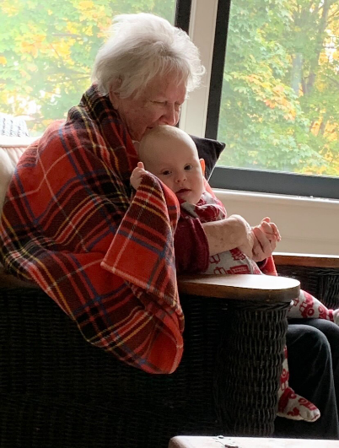
Catherine McEwen Gallant
May 28,1936—August 14, 2021
Catherine spent her early life in Rollo Bay and Souris, PEI. After graduating from High School, she entered the nursing program at the Charlottetown Hospital School of Nursing and graduated as a Registered Nurse in 1957. Shortly after she married Mike Gallant also from Eastern PEI. She continued nursing as they moved from place to place following Mike in his banking career. They finally settled in Charlottetown, PEI where they raised a family of six.
Catherine always had a reputation as a reliable, sensitive and caring nurse. Her greatest legacy was her gift of presence to her husband, their family and extended family. At one time she left her nursing job so she would be available to look after the grandchildren while the young parents went out to work. She developed a warm relationship with these young people and continued to be a guide and support for them.
Catherine was actively involved in her community. She was an Associate of the Sisters of St. Martha. She was also a member of the McKillop Centre for Social Justice which had as its focus Child and Family Poverty on PEI. Catherine had a highly developed social conscience which drew her to help the most vulnerable and which complemented the true spirit of our Christian Life Community, Companions on the Way.
As a member of her Christian Life Community she was a woman of great wisdom and with a deep life of prayer. Decisive and committed, she could move into action wherever she was needed. She played an integral part in the settlement of an African Refugee family and often included her whole family in supporting this mission. At the time of her passing she was involved in our CLC’S present mission,” PEI Fight for Affordable Housing.”
Pope Francis says,” a sense of humor is a necessary human attribute and the closest to God’s grace.” It would seem Catherine had received an abundance of God’s grace. She had a way of brightening any room with her quiet and ready wit.
Though having lived with a chronic illness, her sudden passing came as a shock. She will now be reunited with her beloved son Robert. It is with much love and gratitude that her family and friends will remember her.
May she rest in peace.

